**Project Report**

**CLUSY OS  
Clustered Operating System**

**Submitted By: Firnas Ahamed**

**Date of Submission: 14/03/2024**

# ****Abstract****

Table of Contents

Abstract 1

1. Introduction: 4

2. Device Information: 5

2.1 Device Specifications 5

2.2 Common Usage Scenarios: 5

2.2.1 Multimedia Applications 5

2.2.2 Gaming 5

2.2.3 Productivity Tasks 5

2.3 Device Special Features 6

2.3.1 Camera Capabilities 6

2.3.2 Sensors 6

2.4 Compatibility and Hardware Resources 6

3. Requirements 7

3.1 High Availability 7

3.2 Load Balancing 7

3.3 Fault Tolerance 7

3.4 Scalability 8

3.5 Resource Management: 8

3.6 Security and Authentication: 8

3.7 Data Synchronization: 8

3.8 Performance Optimization: 9

3.9 User Experience: 9

4. Architecture Choices: 10

4.1 Shared-Nothing Architecture 10

4.1.1 What Is Shared Nothing Architecture? 10

4.2 Master-Slave Model 12

4.2.2 What is Master-Slave Model? 12

5. Memory, Device, and File Management Policies 15

5.1 Memory Management 15

5.2 Device Management 15

5.3 File Management 16

6. Reliability, Performance, and Portability Strategies 17

6.1 Reliability 17

6.2 Performance 17

6.3 Portability 17

7. Assumptions 18

7.1 Hardware Reliability 18

7.2 User Behavior 18

7.3 Device Selection 18

7.4 Device Usage 18

7.5 Operating System Requirements 18

7.6 System Architecture 18

7.7 Critical Evaluation of Architecture 18

8. Critical Evaluation 19

8.1 Advantages of the Chosen Architecture 19

8.2 Potential Challenges of the Chosen Architecture 19

8.3 Complexity of Distributed Memory Management 19

8.4 Trade-offs in Memory Management 20

9. Existing Research 20

9.1 Influential Research Papers 20

9.2 Insights Gained from Research 21

11. References 22

# 1. Introduction:

# 2. A step by step progress how

## 2.1 Environment Setup

1. Github Repo created

2. Install Laravel: First, you need to install Laravel. You can do this via Composer, assuming you have Composer installed on your system. Run the following command in your terminal:

composer create-project --prefer-dist laravel/laravel webmail-laravel

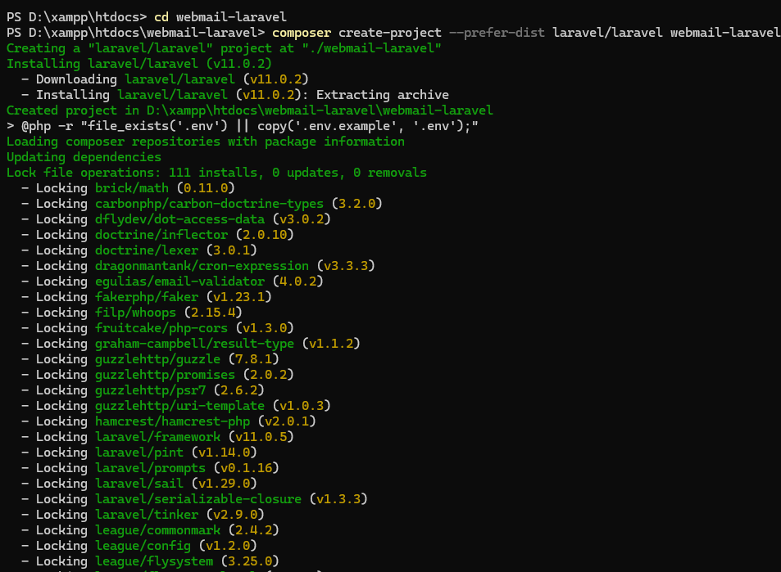

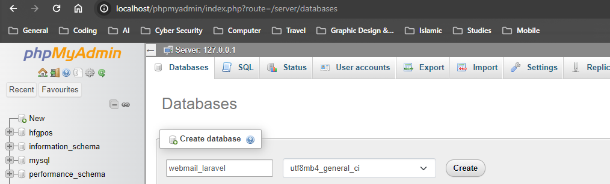3. DB Creation in MYSQL PHPmyadmin

4. Database Configuration: Make sure your database connection details are correctly configured in the .env file.

5. Migration: Create a migration for the email table by running the following command:

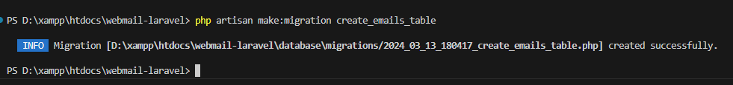php artisan make:migration create_emails_table

6. edited the Migration File with these commands additionally

Schema::create('emails', function (Blueprint $table) {

            $table->id();

            $table->string('recipient');

            $table->string('subject');

            $table->text('message');

            $table->enum('status', ['sent', 'draft'])->default('draft');

            $table->timestamp('sent_at')->nullable();

            $table->timestamps();

        });

    }

7. Migration Command

8. Implement Laravel Default User Authentication

Install Laravel Breeze:

let's install Laravel Breeze for authentication:

composer require laravel/breeze --dev

9.asas

10.

php artisan serv

and register a user

Changed the welcome page